**Version Controlling Activity # 4**

**20K-0409 Mukand**

**After creating project**

**Task 1: Forking actionsdemos/calculator site:**

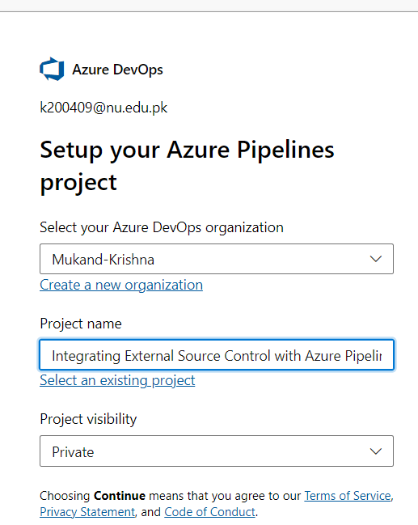

**Task 2: Configuring your Azure Pipelines project**

**Creating Pipeline:**

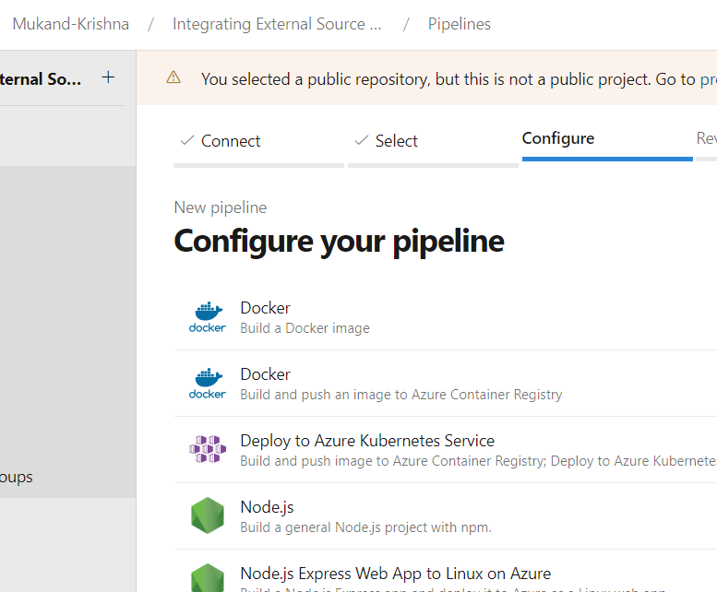

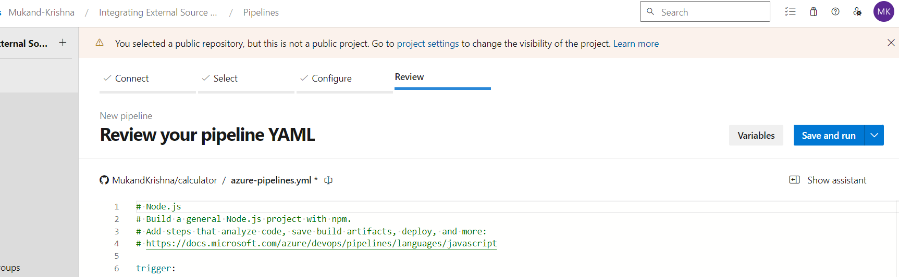

**Made self-hosted agent in pc because agent wasn’t granted after filling form.**

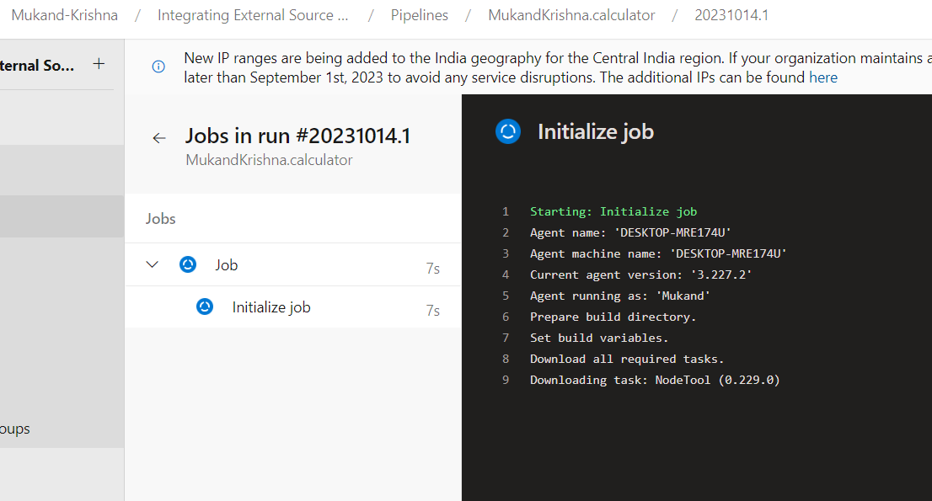

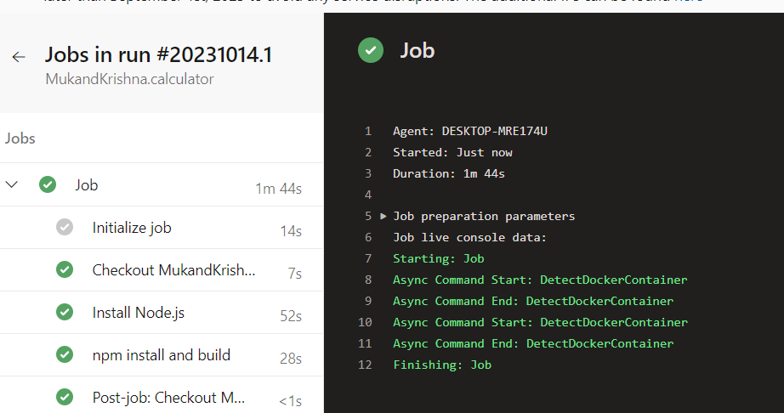

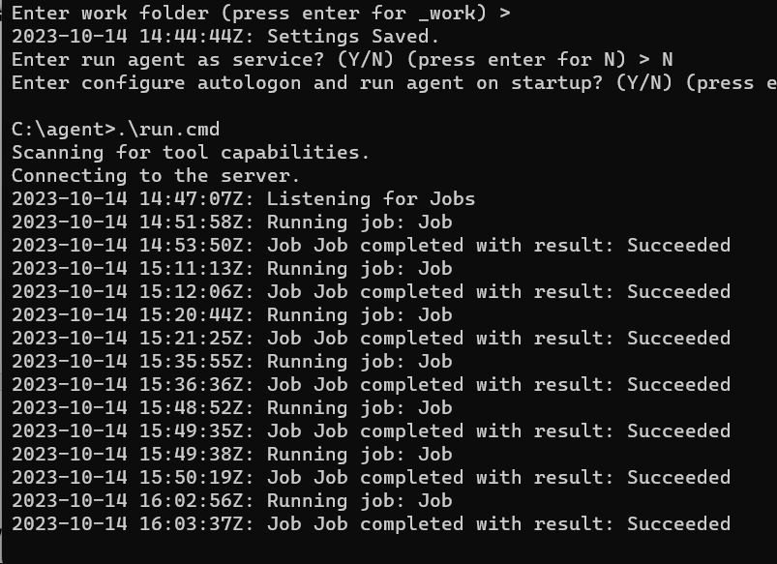

**Task 3: Modifying a YAML build pipeline definition**

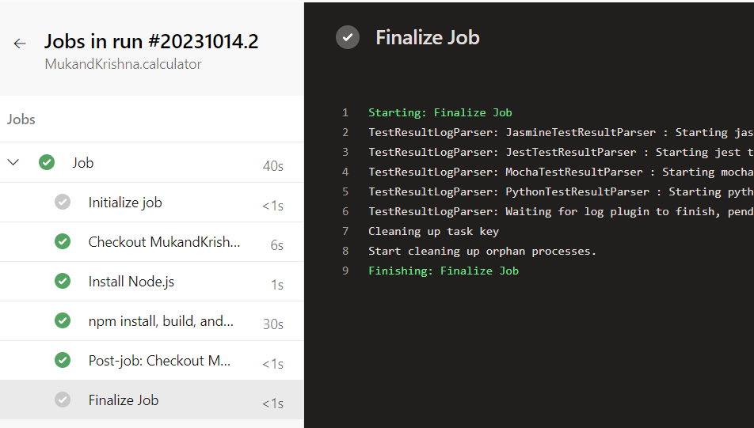

**Task 4: Proposing a change via GitHub pull request**

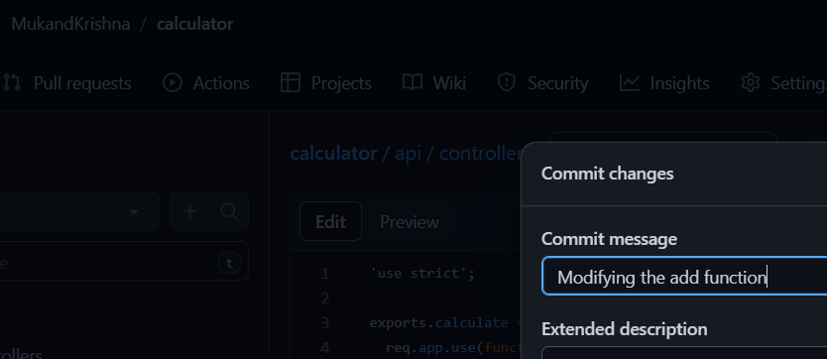

**Task 5: Using the broken pull request to improve the project**

**Checks were passed:**

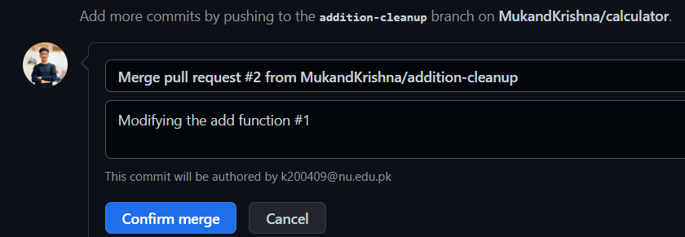

**Task 6: Adding a build status badge**



